**Requirements Document**

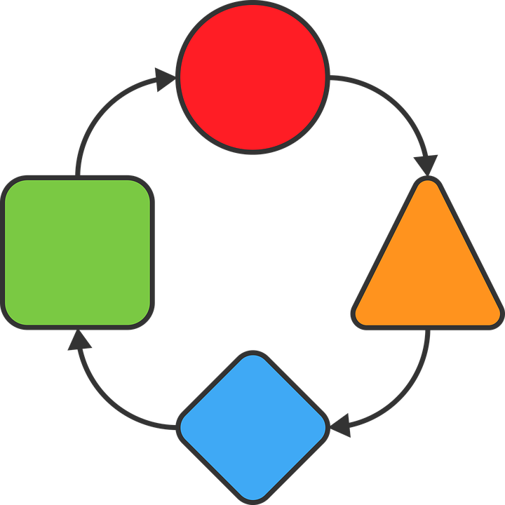

**WQC**

**Version History**

|  |  |  |  |  |
| --- | --- | --- | --- | --- |
| **Data** | **Versão** | **Descrição** | **Autor** | **Revisor** |
| 25/10/19 | 1.0 | Initial version | Richard Cardoso | - |
| 29/10/19 | 1.1 | 1. Changed BR006’s report id from ‘5033’ to ‘5035 | Richard Cardoso |  |

|  |  |
| --- | --- |
| **Client** | Weger Walter GmbH |
| **Document** | Requirements Document: *WQC* |
| **Date** | 25 October 2019 |
| **Author** | **Richard Cardoso**  richard.cardoso@weger.com.br |

**Signatures**

|  |  |  |
| --- | --- | --- |
| Reviewed and Approved by: |  |  |
|  |  |  |

**Summary**

1. Document goal 4

2. Functional requirements 4

3. Non-functional requirements 5

4. Business rules 5

Document goal

This document describes the WQC system’s requirements.

1. Functional requirements

|  |  |  |
| --- | --- | --- |
| **ID** | **Description** | **P.S.** |
| FR001 | The system should allow a qr-code to be scanned | BR012 |
| FR002 | The system should retrieve from the server some pdf documents that belongs to the project to which the qr-code referees to | BR003 |
| FR003 | The system should scan all the project’s subfolders in order to retrieve all pdf documents that can be parsed to a report file (by having the filename beginning with one of the report types codes) | BR011 |
| FR004 | The system should allow the user to add checks (marks) onto the reports |  |
| FR005 | The system should save a copy of the original pdf’s and this copy should contain the marks added by the users |  |
| FR006 | The system should allow users to fill a predefined form of items with a state (approved, not approved, not applicable, not checked) | BR005, BR006, BR007, BR008 |
| FR007 | For each of those items, the system should allow the user to take a picture which will refer to the corresponding item |  |
| FR008 | The system should store each one of those items state and properties |  |
| FR009 | The system should allow the user to inform data about the customer that requested this project |  |
| FR010 | The system should allow the user to take several project-related pictures (shared across all drawings and parts of the same project) |  |
| FR011 | The system should export/save all data (marked reports and taken pictures) to the fileserver |  |
| FR012 | The exported/saved data should always be up to date (it should be updated whenever a change is made by any user) |  |
| FR013 | The system should allow multiple users to work with the app at the same time (multi-user feature) |  |
| FR014 | The multi-user feature should work even when two or more users are working at the same entity (i.e. at the same report) |  |
| FR015 | The system should identify each one of the devices individually |  |
| FR016 | The system should allow devices to be registered / edited / enabled / disabled |  |
| FR017 | The system should allow to assign one or more roles to each device. |  |
| FR018 | Roles are defined as following  Short label: TE, Full label: Technician. This role has read-only access to the project’s contents.  Short labels: MG, EL, QC. Full labels: Magazine, Electrician, Quality-control: Those roles have read-write access to the project’s contents. |  |
| FR019 | All roles can capture general pictures. |  |
| FR020 | The assigned roles short label (MG, TE, …) should be shown up at each of the marks that the user adds to the reports surrounded. |  |
| FR021 | Only authorized devices can access data from the projects |  |
| FR022 | All pictures should be saved inside the ‘Fotos’ folder of the corresponding project folder |  |
| FR023 | All reports generated by the system should be saved inside a folder named ‘Qualitaetskontrol’. This folder should be located at the corresponding project folder (according to the qr-code) |  |

1. Non-functional requirements

|  |  |  |
| --- | --- | --- |
| **ID** | **Description** | **P.S.** |
| NFR001 | The file upload feature should work at both windows/linux server |  |
| NFR002 | The backend code must run at both windows/linux application server |  |
| NFR003 | The mobile client must run under Android 8.0 or greater |  |

1. Business rules

|  |  |  |
| --- | --- | --- |
| **ID** | **Description** | **P.S.** |
| BR001 | Projects are composed of one or several devices/drawings |  |
| BR002 | Devices are composed of one or several parts |  |
| BR003 | Each device has one or several report files |  |
| BR004 | Each report can be either a report with predefined items or a pdf document |  |
| BR005 | Predefined items reports have a list of items whose status needs to be informed |  |
| BR006 | Predefined items report id is 5035 |  |
| BR007 | Each item has: description, comments and a status |  |
| BR008 | Each item status can be either: Approved, Not approved or Not applicable |  |
| BR009 | Pdf document reports are represented by pdf files |  |
| BR010 | Pdf document report’s files can be inside any subfolder of the project folder |  |
| BR011 | Each pdf report file starts with a 4-digits number that identifies the report type according to the following:  5001: Non-wired drawing file  5002: Non-wired datasheet file  5032: Wired drawing file  5033: Wired datasheet file |  |
| BR012 | Each part (physically speaking) is identified by a qr-code (attached to it) |  |
| BR013 | Every qr-code has the following structure: \xx-y-zzz_ Z_n_T_x, where: |  |
| BR014 | xx: year in which the project has been executed  y: location (which company factory) in which the project has been executed  zzz: project number  n: drawing number  x: part number |  |
| BR015 | All project files are stored at a root folder named ‘Auftrag’, within a file server |  |
| BR016 | Inside the root folder, there is one folder for each past year and another for the current one |  |
| BR017 | Folders inside the root folder have a name that follows the following structure: xx-y-___, where:  xx: year in which the project has been executed  y: location (which company factory) in which the project has been executed |  |
| BR018 | Each of those folders contains a project folder whose name follows the following structure: xx-y-zzzz, where:  xx: year in which the project has been executed  y: location (which company factory) in which the project has been executed  zzz: project number |  |
| BR019 | Inside each project folder a lot of folders may exist. Among those there is a folder named ‘Fotos’, where the project’s pictures should be stored. |  |